Sprint A Review

* **Architectural choices**

1. NodeJS for backend
2. ReactJS for frontend

The reason behind those choices is the single language architecture and open-source documentation/technology.

It was discussed and approved in the first meeting with the Project Owner.

* **Project plan**

Delivered on time (can be found on Canvas). Waiting for feedback.

* **GitHub and Definition of Done**

Project Owner and our Tutor have access to our GitHub repositories and Board (planning tool). => BE ([View 1 · Back-End board (github.com)](https://github.com/orgs/Group-One-Fontys-Ordina/projects/3)) FE ([View 1 · Front-End board (github.com)](https://github.com/orgs/Group-One-Fontys-Ordina/projects/5))

The group has chosen to employ a branching method where each member has their individual branch to work on. Once they've completed their tasks, they submit a merge request. Both the SCRUM master (Danko) and Bogdan review these requests. This approach guarantees quality control, dual feedback, and verification against the acceptance criteria of the US/Task.

Stand up attendance can be seen in the other document (Stand Ups history).

* **Preparation for the Review with the PO**

Our approach is to present our accomplishments (explain the choices made) and some preliminary designs for the website to gather feedback. We will ask several questions to clarify any ambiguities.

**Here are the questions we've prepared:**

1. Are the new wireframes sufficient?
2. Do offices have a capacity for check-in?
3. What can a user do on the website?
4. Is scheduling a meeting needed or just an invitation?
5. Should there be a chat feature?
6. Login based on email or username?
7. User creates an account or is given one?

We aim to gain a clearer understanding of the specific requirements for the website. Currently there are differences between our perception and the Product Owner's vision, which we intend to resolve.

**Here are the wireframes (for the PO meeting):**

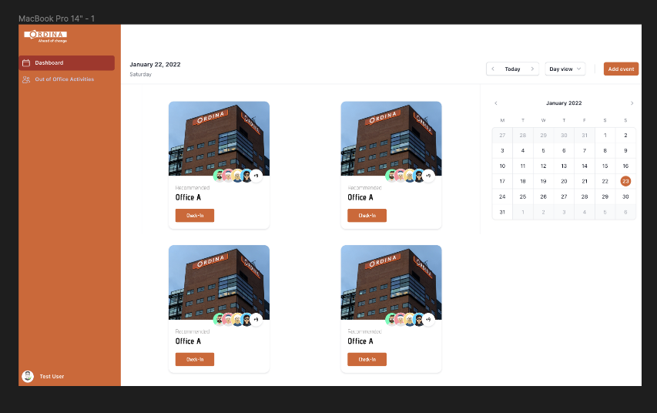

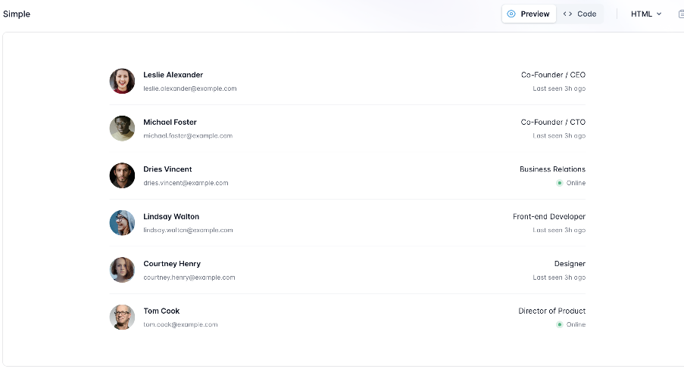

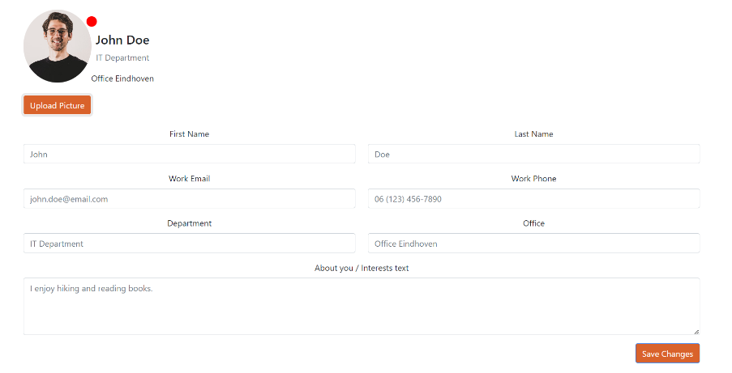

* **Sprint B planning**

We have completed our research phase. This was our primary objective for Sprint A, and our attention will now shift to implementation. However, should there be any changes arising from feedback by the Product Owner, we're open to revisiting our research. Now that we're aware of our working speed, we have a clearer insight into our capacities. Our future planning takes this into account, and the features for the next sprint will be discussed with the Product Owner.